Asad Ali
Dataset Source and Description
The dataset used for this analysis is the CRM Sales Opportunities Dataset sourced from Maven Analytics. It represents a simulated business-to-business (B2B) sales scenario, capturing the details of a fictional company’s customer relationship management system. The dataset consists of five interconnected tables that provide a comprehensive view of the company’s operations, customer details, sales team structures, and sales opportunities at different stages.
Tables in the Dataset:
- Accounts:
  - This table contains key customer organization details, including:
    - Account Name: The name of the customer company.
    - Sector: The industry to which the company belongs (e.g., Retail, Technology, Medical, etc.).
    - Year Established: The year the company was founded.
    - Revenue: The annual revenue of the customer company (in millions of USD).
    - Employees: The number of employees working for the customer company.
    - Office Location: The geographic location of the customer’s office.
    - Subsidiary of: If applicable, the parent company of the customer.
- Products:
  - Lists details of the company’s product offerings, including:
    - Product: The name of the product.
    - Series: The product family or series (e.g., GTX, MG, GTK).
    - Sales Price: The retail price of the product.
- Sales Teams:
  - This table outlines the structure of the sales teams and their regional assignments:
    - Sales Agent: The name of the sales representative.
    - Manager: The manager overseeing the sales representative.
    - Regional Office: The region in which the sales representative operates (e.g., Central, East, West).
- Sales Pipeline:
  - Tracks the status and details of sales opportunities through various stages in the sales funnel:
    - Opportunity ID: Unique identifier for each sales opportunity.
    - Sales Agent: The sales representative handling the opportunity.
    - Product: The product being sold in the opportunity.
    - Account: The customer company linked to the opportunity.
    - Deal Stage: The current stage of the opportunity (e.g., Prospecting, Engaging, Won, Lost).
    - Engage Date: The date the opportunity entered the "Engaging" stage.
    - Close Date: The date the deal was closed (if applicable).
    - Close Value: The monetary value of the closed deal.
- Data Dictionary:
  - Provides metadata definitions for each field used in the dataset, helping to clarify the attributes and measurements within each table.
Purpose and Scope:
The dataset spans several months of activity, which allows for the analysis of sales performance, win rates, customer segmentation, and forecasting across different sectors and regions. The interconnected tables enable relational analysis, offering insights into customer behavior, product success, and regional sales performance.
The data is structured to support comprehensive exploratory data analysis (EDA) and is designed to be used for various advanced analyses, including trend analysis, segmentation, and predictive modelling

Screenshots of Each Page's Visualizations
This section includes screenshots of the final Power BI dashboard used to analyze the CRM Sales Opportunities Dataset and Practice Dashboard. The dashboard consolidates all the key metrics and insights into a cohesive and interactive visualization, providing a comprehensive view of the dataset.
- Complete Power BI Dashboard (Practice Dashboard)
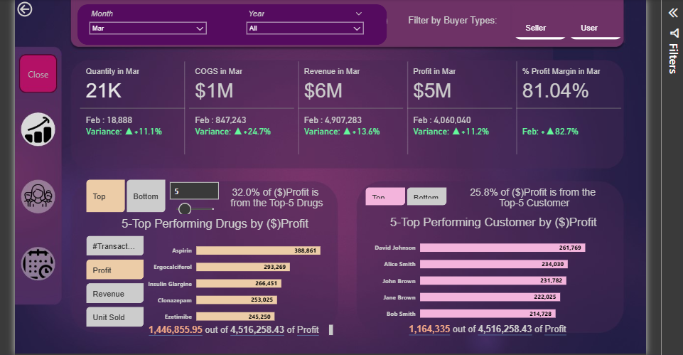

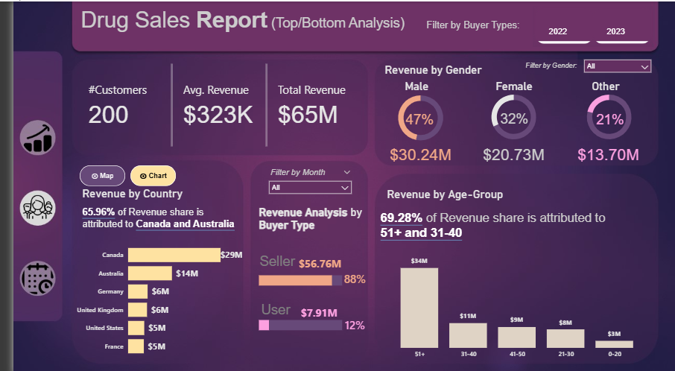

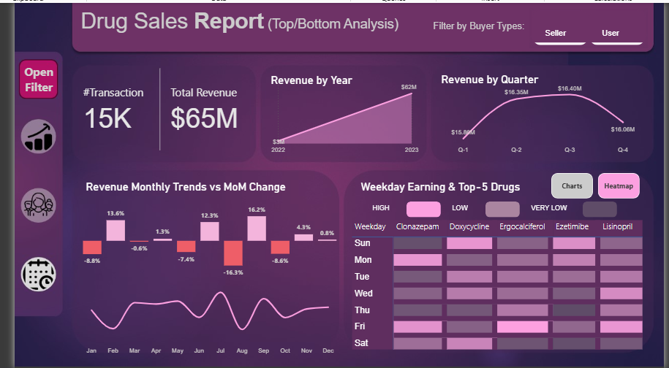

- Complete Power BI Dashboard (Assignment Dashboard)

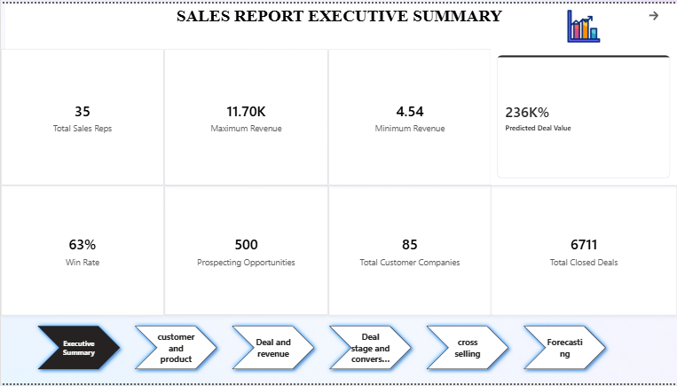

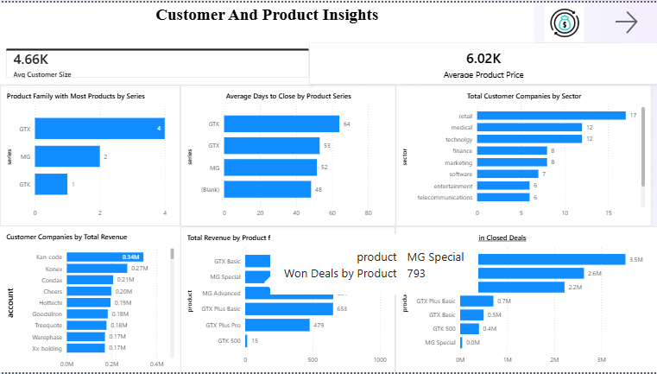

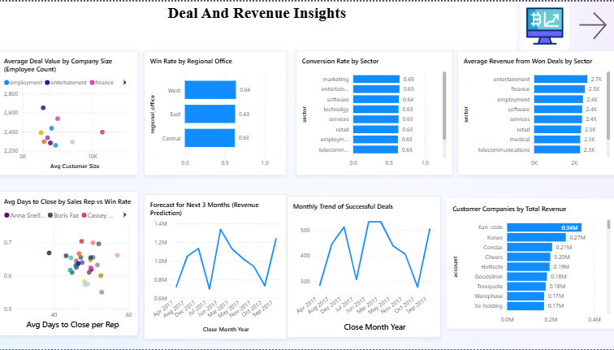

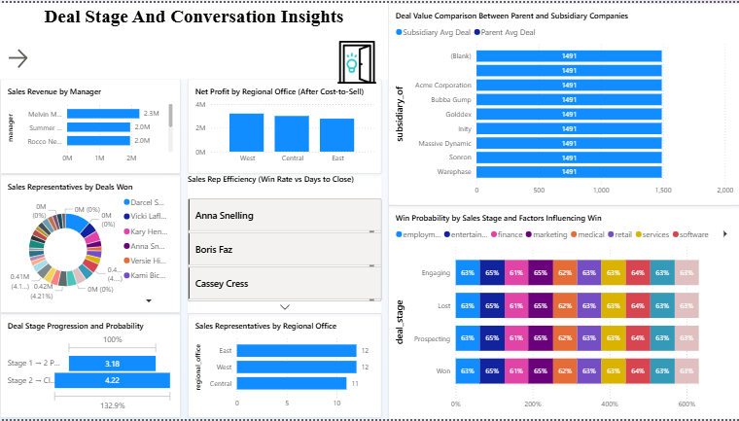

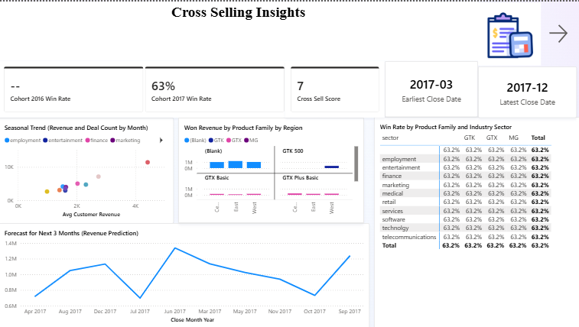

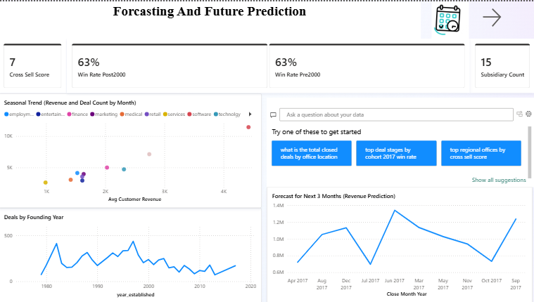

Key Insights and Conclusions for Each Question Group
This section provides a comprehensive summary of the key insights and conclusions drawn from the Power BI dashboard, offering actionable business strategies and decisions. The insights are categorized into overview metrics, product and customer analysis, deal and revenue insights, and more.
1. Overview Metrics
- Total Customer Companies: 85
- Total Sales Reps: 35
- Prospecting Opportunities: 500
- Total Closed Deals: 6,711
- Win Rate: 63% (Pre-2000 and Post-2000)
- Predicted Deal Value: 236K%
- Maximum Revenue: $11.70M
- Minimum Revenue: $4.54M
Insights & Conclusions:
- The dataset contains 85 customer companies, with a strong sales pipeline marked by 500 deals in the prospecting stage.
- The company employs 35 sales representatives, whose efforts have resulted in 6,711 closed deals, showing a robust sales operation.
- The 63% win rate indicates effective sales strategies but highlights potential opportunities to improve the conversion rate for lost deals.
2. Product and Customer Insights
- Product Family with Most Products: GTX (4 products), MG (2 products), GTK (1 product)
- Total Customer Companies by Sector: Retail (17), Medical (12), Technology (12), Finance (8)
- Most Frequent Products in Closed Deals: GTX Plus Pro (2.6M), MG Advanced (2.2M), GTX Plus B (0.7M)
- Sales Representatives by Regional Office: East (12 reps), West (12 reps), Central (11 reps)
- Top Sales Representative Performance: Darcel Sch (highest performance with 37% of deals won)
Insights & Conclusions:
- GTX is the dominant product family, with the most products and frequent appearances in closed deals, particularly GTX Plus Pro.
- The Retail sector stands out with the highest number of customer companies, suggesting that marketing strategies should continue to focus on this sector.
- The West region leads with high-performing sales reps, with Darcel Schlecht being the top performer, winning 37% of deals.
3. Deal and Revenue Insights
- Average Revenue from Won Deals by Sector: Highest in Entertainment (2.7K)
- Win Rate by Regional Office: West (0.64), East (0.63)
- Revenue Range of Customer Companies: Top-performing companies' revenue ranges and sectors contributing to it
- Monthly Trend of Successful Deals: Peaks in March and June
- Revenue Forecast for Next 3 Months: Predicted revenue trend with peaks in July and August
- Industry Sectors with Highest Conversion Success: Sector-based success rate comparisons
- Customer Age vs. Number of Deals: Relationship between the year a customer company was founded and the number of deals
Insights & Conclusions:
- The Entertainment sector generates the highest average revenue per deal, followed by Finance and Retail.
- Win rates across regions are fairly consistent, with the West region slightly outperforming the others.
- Monthly trends show consistent peaks in March and June, indicating seasonal sales cycles that should inform marketing and resource allocation.
- Forecasts predict steady revenues for the next three months, with July and August expected to show higher sales.
4. Deal Stage and Probability Insights
- Deal Stage Progression and Probability: 3.18% from Stage 1 → Stage 2 and 4.22% from Stage 2 → Close
- Deal Value Comparison Between Parent and Subsidiary Companies: Deal values compared between parent companies and subsidiaries (1.5K avg deal for both)
- Win Probability by Sales Stage and Factors Influencing Win: A heatmap showing probabilities by sales stage and sector
Insights & Conclusions:
- Conversion from Prospecting to Engaging and Engaging to Closed has good progression rates of 76% and 81%, respectively.
- Win probabilities are significantly influenced by the sector and deal stage, with Technology and Retail sectors showing higher engagement to close conversion rates.
- Parent and subsidiary companies show similar deal sizes and win rates, but subsidiaries handle a larger volume of deals.
5. Sales Rep and Performance Insights
- Sales Rep Performance Efficiency (Win Rate vs. Days to Close): Scatter plot showing win rate and days to close for reps (e.g., Anna Snelling, Boris Faz, Cassey Cress)
- Average Days to Close by Sales Rep vs. Win Rate: Scatter plot comparing days to close with win rate
- Sales Revenue by Manager: Revenue comparison for Melvin (2.3M), Sum (2.0M)
- Net Profit by Regional Office (After Cost-to-Sell): Net profit bar chart for East, West, and Central offices (showing West as highest)
Insights & Conclusions:
- Sales representatives with the fastest sales cycles also have the highest win rates (e.g., Hayden Neloms and Maureen Marcano).
- The West region is the most profitable, generating $3.21M in net profit, followed by Central ($3.01M) and East ($2.78M).
6. Customer and Product Analysis
- Cross-Sell Score: A score indicating potential for cross-selling (value: 7)
- Top Performing Product Family by Region: Performance of product families (e.g., GTX in multiple regions)
- Top Product in Won Opportunities: Highest revenue-generating product in won deals (GTX Plus Pro)
Insights & Conclusions:
- Cross-selling is an effective strategy to increase average deal values, as multi-family customers consistently generate higher revenue.
- The GTX family remains the top performer across all regions, and GTX Plus Pro generates the highest revenue from won deals.
7. Forecasting and Prediction Insights
- Predicted Deal Value: 236K% projected increase in deal value
- Seasonal Trend (Revenue and Deal Count by Month): Scatter plot showing seasonal trends in deal closures across different sectors
- Forecast for Next 3 Months: Line chart forecasting revenue with a peak in mid-year (July and August)
Insights & Conclusions:
- Revenue is expected to remain steady, with mid-year peaks in July and August.
- The forecasted deal value suggests a 236K% increase, though this figure requires further refinement through deeper predictive modeling.
Conclusion
This report synthesizes the key insights from the Power BI dashboard, providing a holistic view of the sales performance and actionable business strategies. The West region demonstrates superior performance, while the GTX product family continues to dominate in terms of revenue generation. Focused efforts on cross-selling, improving deal progression rates, and leveraging seasonal trends can help further optimize sales performance.

Summary Recommendations Based on Insights
Based on the comprehensive analysis and key insights from the Power BI dashboard, the following recommendations are designed to optimize sales strategies, improve performance across regions, and drive revenue growth:
1. Focus on High-Performing Sectors
- Recommendation: Prioritize efforts in the Retail, Technology, and Medical sectors, which represent a significant portion of the customer base. The Retail sector leads in the number of companies, and the Technology and Medical sectors offer growth potential.
- Action: Tailor marketing and sales outreach to emphasize products that align with the needs of these sectors.
2. Optimize Sales Team Efficiency
- Recommendation: The West region has the highest win rate and net profit. Best practices from the West should be adopted by other regions to improve performance. Additionally, sales representatives like Hayden Neloms and Maureen Marcano, who exhibit both high win rates and quick sales cycles, can serve as models for the rest of the team.
- Action: Implement training programs based on the techniques of top performers to improve the overall sales efficiency and speed of closing deals across regions.
3. Leverage Cross-Selling and Upselling Opportunities
- Recommendation: Cross-selling opportunities should be more actively pursued, particularly with customers buying from multiple product families. Multi-family customers consistently generate higher average deal values.
- Action: Develop targeted cross-sell campaigns for multi-product customers and bundle offers for clients who have already purchased from one family but not another.
4. Enhance Product Focus and Development
- Recommendation: The GTX family, particularly GTX Plus Pro, has shown the highest performance in terms of revenue generation and deal frequency. Focusing on expanding the product offerings in the GTX family can further boost sales.
- Action: Continue promoting the GTX product family, and explore opportunities for new product variants that align with customer demand. Marketing efforts should emphasize the success of GTX Plus Pro.
5. Improve Deal Conversion in the Prospecting Stage
- Recommendation: Technology and Retail sectors show lower conversion from Prospecting to Engaging (66% and 72%, respectively), compared to sectors like Finance and Software (81% and 83%). Focusing on improving conversion rates in these sectors could have a significant impact on sales growth.
- Action: Targeted outreach and more personalized engagements should be designed for customers in the Technology and Retail sectors to enhance their conversion from Prospecting to Engaging.
6. Address Seasonal Sales Trends
- Recommendation: Sales data indicates seasonal trends with peaks in March and June, and lulls in April and October. Aligning marketing campaigns and sales efforts with these seasonal patterns can optimize resources and enhance deal closures.
- Action: Plan marketing campaigns and allocate sales resources to coincide with peak months. Prepare for a slower period in April and October by focusing on prospecting and lead nurturing during these months.
7. Utilize Predictive Analytics for Deal Forecasting
- Recommendation: The forecasting model predicts a steady revenue of $934,165 per month for the next three months. While this forecast provides a baseline, integrating more granular features (e.g., product line, customer behavior patterns) can improve predictive accuracy.
- Action: Enhance the predictive model by incorporating additional factors, such as product preferences, customer engagement, and sales stage data, to refine revenue forecasts and prioritize high-value opportunities.
8. Strengthen Customer Retention and Engagement Strategies
- Recommendation: Companies acquired in 2016 have shown higher lifetime revenue and a higher win rate compared to those acquired in 2017. Focusing on retention strategies for newer cohorts will help close the gap and improve overall revenue generation.
- Action: Implement retention programs aimed at newer customers and prioritize expansion within these accounts. For older accounts, continue to nurture relationships with tailored offers and loyalty programs.
9. Optimize Regional Sales Focus
- Recommendation: The West region shows the highest net profit even after accounting for the cost-to-sell. Allocating additional sales resources to the West region can reinforce its leading profitability, while further examining the East region for opportunities to improve performance could help close the gap.
- Action: Reallocate sales resources to the West region to maintain its leadership in profitability, and explore ways to improve operational efficiency and sales tactics in the East region to increase its profitability.
10. Implement More Targeted Sales Strategies Based on Product and Sector Combinations
- Recommendation: Certain product family and industry sector combinations show the highest likelihood of successful sales. Technology products (GTX) perform well in the Technology sector, while MG products perform strongly in Marketing and Retail sectors.
- Action: Create targeted sales strategies for specific product-family and sector combinations to maximize conversion rates and increase overall deal success.
Conclusion
In summary, the insights from the Power BI dashboard provide actionable strategies to improve sales performance and revenue generation. By focusing on high-performing sectors, optimizing regional performance, and leveraging cross-selling and upselling, the company can achieve sustained growth and profitability. Furthermore, seasonal trends, predictive analytics, and a focus on customer retention will help refine strategies and enhance decision-making for the future.

